Project Scenario
As a regional manager for a chain of car dealerships you need to build out a dashboard to allow you to understand your sales and service departments.

TASK
Create two dashboards as follows:
- One dashboard using the tabbed template that has 4 small rectangles at the top and a large rectangle below - rename this dashboard tab to Sales.
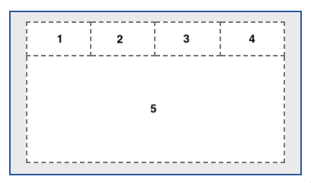

- One dashboard using the 2 x 2 rectangle areas tabbed template - rename this dashboard tab to Service.
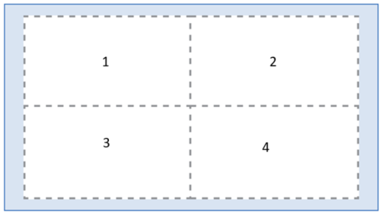

Capture the following KPI metrics as visualizations:
- On the Sales dashboard, capture the following KPI metrics:
  - In the first small rectangle (Panel 1), capture Profit (formatted to 1 decimal place in millions of US dollars)
  - In the second small rectangle (Panel 2), capture Quantity sold
  - In the third small rectangle (Panel 3), capture Quantity sold by model (as a bar chart)
  - In the fourth small rectangle (Panel 4), capture Average quantity sold

- On the Sales dashboard in the large rectangle (Panel 5), display ‘Profit’ by ‘Dealer ID’ as a column chart, sorted in ascending order.

- On the Service dashboard, capture the following KPI metrics as visualizations:
  - In the top left area (Panel 1), capture the number of recalls per model of car (as a column chart)
  - In the top right area (Panel 2), capture the customer sentiment by comparing positive, neutral, and negative reviews (as a treemap)
  - In the bottom left area (Panel 3), capture the quantity of cars sold per month compared to the profit (as a line and column chart).
  - In the bottom right area (Panel 4), capture the number of recalls by model and affected system (as a heat map). This will help us understand if there are any outliers for a given model or a specific system.

